[Header]
Dear _____________:
Spring has Sprung! Don't forget to take advantage of your exclusive benefits as a member of the UF Alumni Association. Check out some of our special offers below provided by our valued partners or visit our Membership Perks Page for a complete list of offerings. Thank you for being a member of the UFAA.

Membership has it Perks

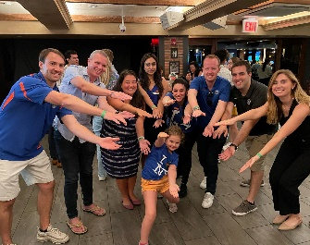Gator Clubs® and Affiliate Groups

Embrace the reality of “The Gator Nation® is Everywhere!” With 70 Gator Clubs® and 9 Affiliate Groups spanning the U.S., the University of Florida’s spirit knows no bounds. Whether you want to reconnect with UF, make a positive impact in your community, or meet fellow Gators in your area, connect with a nearby Gator Club® or an Affiliate Group aligned with your passion. As a current member of the UF Alumni Association, you already belong to your local Gator Club® – get involved today!

UF Bookstore
Shop the latest UF gear with our retail partner, the UF Bookstore. As a member of the Alumni Association, you will receive a 10% discount when shopping by using code UFAASP12024.
Can-Am
Can-Am is a proud to partner with the Gator Nation and offer financing as low as 1.99% for 36 months on select Defender models. For a complete list of promotions, click here
BeachBound
BeachBound Vacations is the perfect place to book your perfect beach vacation. As an online travel agency with expertise in worldwide beach vacations and experiences, customers can book their beach vacation, including flights, hotels, transfers, and excursions, in just a few clicks. A romantic getaway is waiting for you. Book Now and get an extra $100 off sitewide vacation packages.

Herff Jones
Herff Jones takes pride in creating college graduation rings for students and graduates of the University of Florida. Reward yourself with a symbol of excellence by selecting the UF ring which suits your style, experience and achievement. Celebrate being a Gator and wear your pride.
Alumni Travel Program
Greek Isles & Ephesus
9-day, 8-night, 5-star cruise round-trip Athens, Greece, on the Aegean Sea
Call on the islands of Volos, Delos, Mykonos, Patmos, Rhodes, and Santorini on this epic, 8-night voyage. Extend your journey with the Athens Pre-Program and/or Delphi Post-Program Options. For more information, visit: full program here

UFAA Brick Program
Support UF's future and become part of its history with the UFAA Brick Program. Proceeds from this project enhance alumni and academic programs, and support general university needs. Only a limited number of brick spaces are available. Order yours today!

[standard UFAA membership footer]

