HEADER
As the official travel program of The Gator Nation, the UF Alumni Association provides Alumni, their friends and family the opportunity to travel without the hassles of trip planning and logistics. We partner with the best travel providers in the business. All you have to do is sign up and show up!
We offer approximately 20 trips each year, including domestic getaways, European river cruises, African safaris, and journeys around the world! We’ve truly got something for everyone! Every trip booked through the UF Alumni Travel Program helps unite alumni and friends of The University of Florida around the world.
FEATURED TRIPS:
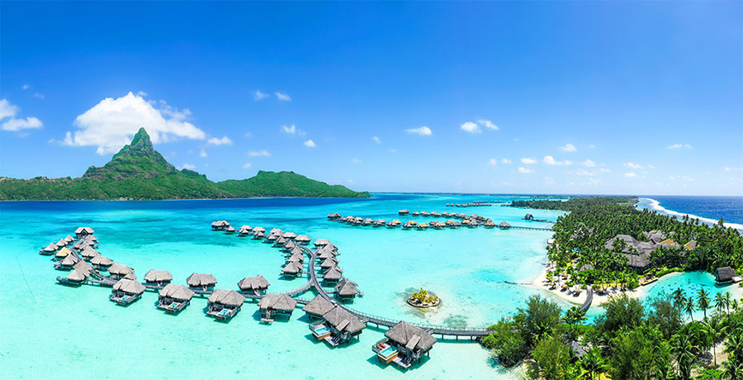
Tahiti & French Polynesia: Experience paradise on Earth as you set sail for the idyllic islands and motus of one of French Polynesia’s most beautiful archipelagos. Formed over millennia by underwater volcanic activity, Tahiti and the celebrated Society Islands—Mo’orea, Ra’iatea, Taha’a, Bora Bora and Huahine—distill the essence and allure of the South Pacific. Explore French Polynesia’s spectacular history, rich culture and unique topography on a luxury itinerary that includes a seven-night cruise aboard the sailing yacht Star Breeze. Choose optional excursions at an additional cost to curate your own adventure and enjoy unmatched small ship sailing amid the splendor of the South Pacific.

Isles of the North: Shetland & Faroe Islands and Iceland
Cruise the storied Northern seas to discover exceptional scenery, islands steeped in Viking lore and remote shores boasting impressive histories and unrivaled natural treasures. Explore islands brimming with fascinating geology and archaeological sites, and gaze in awe at thundering waterfalls and wind-blown hills. Along the way, our experts share their knowledge and perspectives on the histories of these remarkable lands.

Great European Journey: By River and Rail
Embark on an exhilarating European adventure steeped in storied history, grand architecture and breathtaking scenery on this fabulous, 12-day, 11-night itinerary featuring a deluxe river cruise and unforgettable mountain rail journeys. Discover the timeless beauty of the Rhine as you wind past storybook towns, terraced vineyards and forested hills crowned by castles. Marvel at the sweeping grandeur of the Alps on a panoramic train ride that traverses mountain terrain and affords gorgeous views.
Mediterranean Spring: Barcelona to Rome
Set sail along the sunny Mediterranean, where palms line silky sands, Gothic cathedrals shadow buzzing shopping districts, and the best wines in the world complement authentic fare, from tapas to truffles. Try your luck at the swanky Monte Carlo Casino or under the Tuscan hills and sip world-class wines in an ancient Italian wine cellar in Livorno.

National Parks & Lodges of the Old West: Join us on an immersive adventure through the heart of America's most captivating landscapes, traversing the wildlife-rich terrain of Custer State Park, Yellowstone, and Grand Teton National Park. Each engaging day is its own journey, highlighted by exploration of iconic monuments, leisurely hikes, educational discussions, and authentic Old West charm.
For a complete list of 2024 and 2025 trips, please visit our travel partners websites:
PARTNER LOGOS WITH LINKS:

