[Header]
Dear _____________:
Fall has finally arrived and we have some exciting new offers to share with you! Thank you for being a member of the UF Alumni Association. Go Gators!

Membership has it Perks
BRAND NEW FOR UFAA MEMBERS! You now have access to thousands of deals curated specially for The Gator Nation. Our NEW UF Member Perks Discount Marketplace offers shopping, travel, entertainment and lifestyle discounts. Start saving today.

Home Chef is home cooking made simple and delivered right to your door. From 15 minute meals to 30+ minute masterpieces with options for veggie, low-carb or cal-conscious – you’ll find tons of meals that fit your changing schedule and tastes. Pick from meal kit options like our no prep, no mess oven-ready kits or fancy up dinner with our Culinary Collection.
University of Florida Alumni get 19 Free Meals with Home Chef! That’s 50% off your first four boxes. Go to HomeChef.com/GATOR19 and use code GATOR19 to pick your 19 free meals
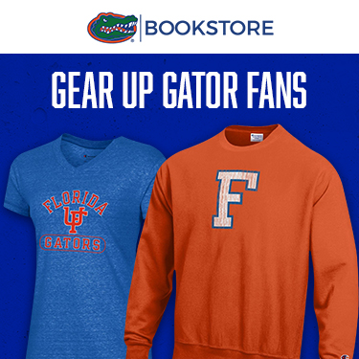 Shop new Fall UF gear with our retail partner, the UF Bookstore. As a member of the Alumni Association, you will receive a 10% discount when shopping by using code UFAAFA12024.

BEAT Shirts – Limited Time
There’s still time to get your 2023 Beat Tees! UFAA Members get a discount – make a gift of $25 for the seasonal BEAT ‘Em All T-shirt or a gift of $60 for this season’s suite, which includes BEAT Arkansas and BEAT FSU Tees!
SPECIAL GAME PRICING – Jags VS. Colts at EverBank Stadium
See former Florida Gator Antony Richardson when the Indianapolis Colts take on the Jacksonville Jaguars at EverBank Stadium on Sunday, October 15. Exclusive offer and special pricing!

Herff Jones
Herff Jones takes pride in creating college graduation rings for students and graduates of the University of Florida. Reward yourself with a symbol of excellence by selecting the UF ring which suits your style, experience and achievement. Celebrate being a Gator and wear your pride.
Commerce Bank
Bring the Gator Nation everywhere you shop, dine or travel with the Florida Gators Mastercard. As a cardholder, you receive a number of great benefits including up to 3% cash back and no annual fee.

UFAA Brick Program
Support UF's future and become part of its history with the UFAA Brick Program. Proceeds from this project enhance alumni and academic programs, and support general university needs. Only a limited number of brick spaces are available. Order yours today!

[standard UFAA membership footer]

